***Output Screenshots***

1. This is the login page where user can login with the credentials. User can sign in with existing login details and if user is new he can use the sign up option to create an account.

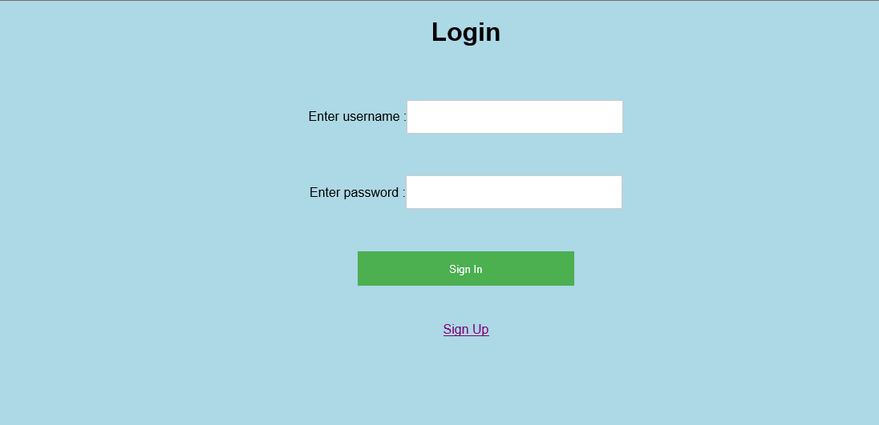

1. This is the below snap where user give wrong credentials and he should give the correct login credentials.

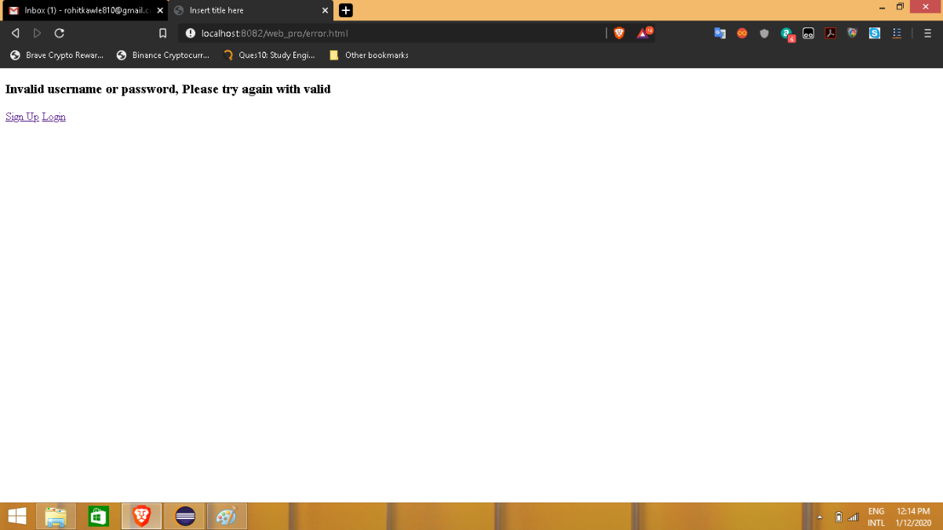

1. This is the below snap where user gives the correct credentials and get a success page.

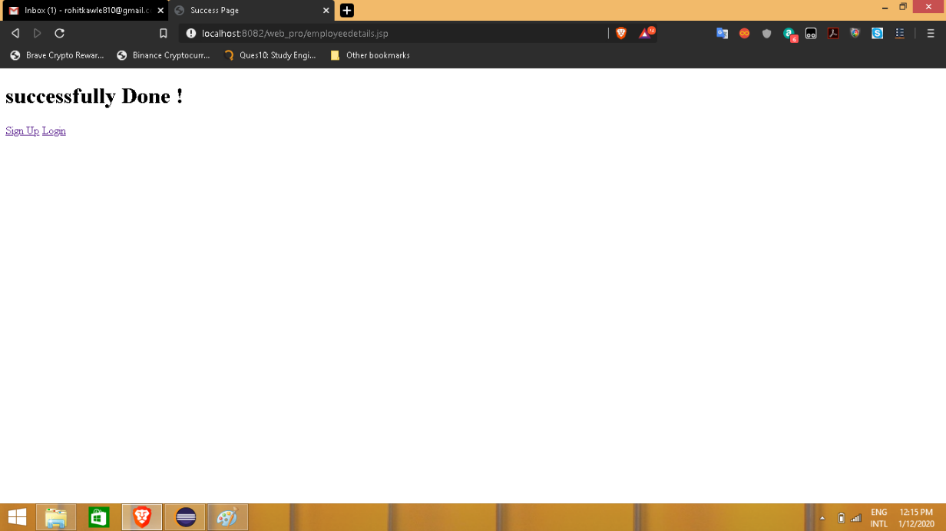

1. This is the registration form when user needs to create the account and have to login.

Where user have to give all the user details like First, Middle, Last names, usernames, Email id, Mob no, Address, Password, and have to re-type the password.

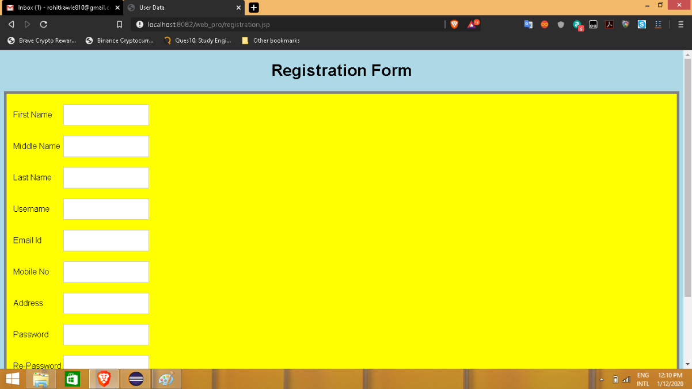

1. The below is the snap where user can see once login. Where user can add the item in cart and can see the different prices based on the shoe product.

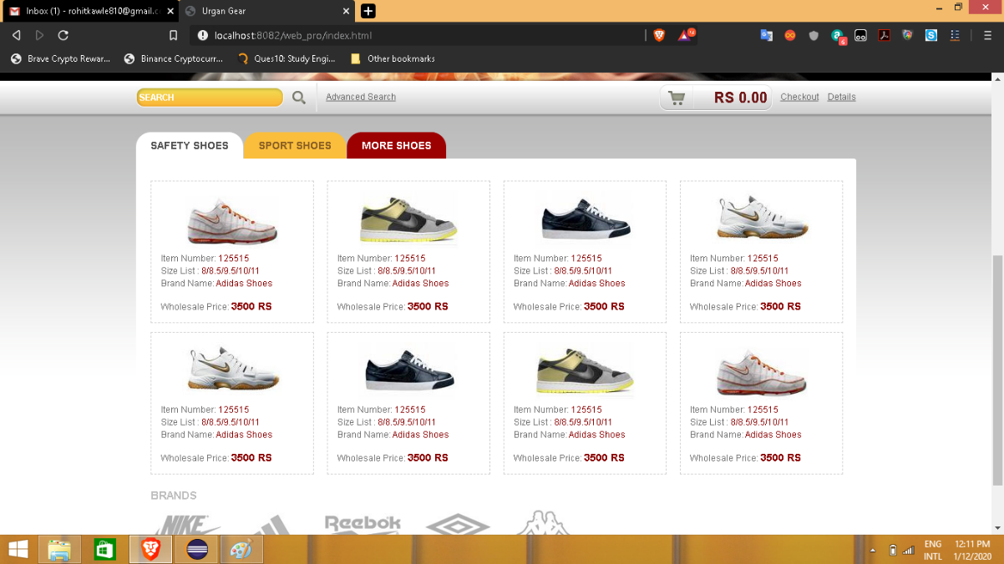

1. The below snap is of different shoes with different options where user can check “safety shoes”, “sport shoes”, “more shoes”

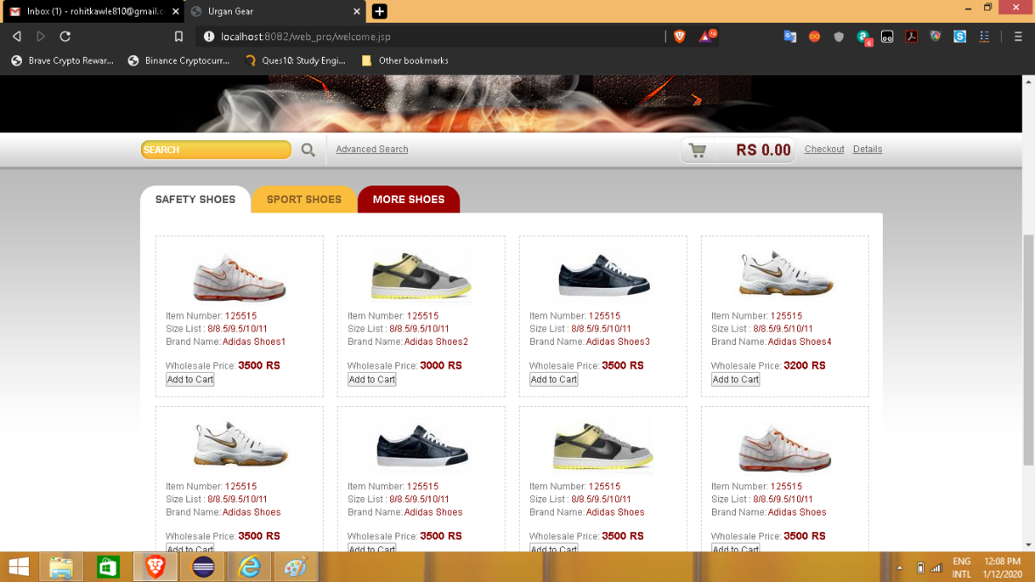

1. In order to contact the support team, the below snaps will appear. User can enter the email and can update the comment and can send.

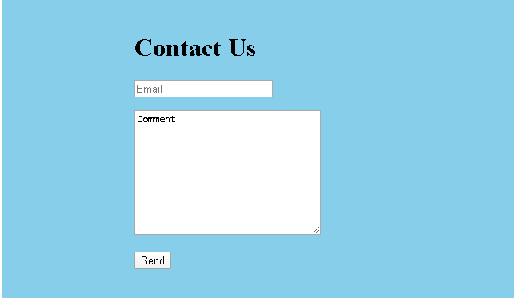

1. This is the final billing data which will appear on the screen where user can see all the details of the product.

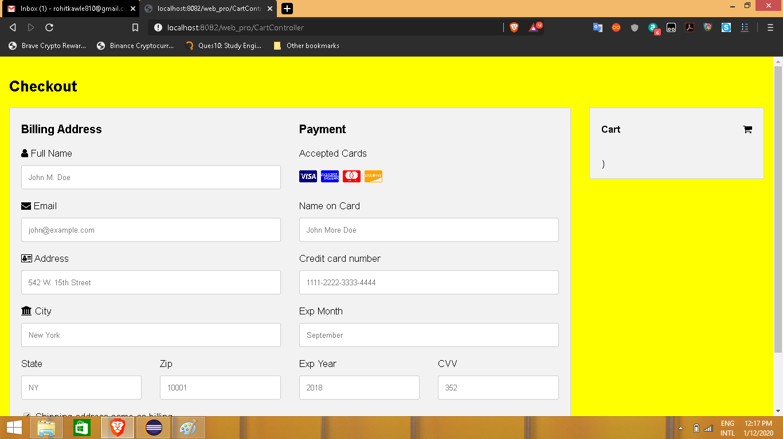

1. This is about the company introduction where users will see the actual ecommerce site details and their background.

